INSTITUTO MEXICANO NORTEAMERICANO DE CULTURA

Final Examination

Teacher’s Name: Adriana Felisa Chávez De la Peña

Student’s Name: _____________________________________

1.-**Vocabulary**. Match the columns according to the translation of the vocabulary.

|  |  |
| --- | --- |
| a) Engineer | 1)Doctor |
| b) Secretary | 2)Bombero |
| c) Nurse | 3)Ingeniero |
| d) Waitress | 4)Pintor |
| e) Lawyer | 5)Enfermera |
| f) Firefighter | 6)Secretaria |
| g) Painter | 7)Enfermera |
| h) Sing | 8)Trepar |
| i) Climb | 9)Mirar |
| j) Dance | 10)Pensar |
| k) Teach | 11)Enseñar |
| l) Take | 12)Soñar |
| m) Look | 13)Cantar |
| n) Think | 14)Tomar |
| o) Dream  p) Head  q) Mouth  r) Leg  s) Knee  t) Elbow  u) Neck  v) Eyes  w) Nose  x)Building  y)Salty | 15)Bailar  16)Ojos  17)Pierna  18)Nariz  19)Cabeza  20)Cuello  21)Codo  22)Boca  23)Rodilla  24)Salado  25)Edificio |

2.- **Numbers**. Write the name of the numbers below.

a) 8 _________________________ f) 5 _________________________

b) 17 _________________________ g) 19 _________________________

c) 50 _________________________ h) 20 _________________________

d) 749 _________________________ i) 423 _________________________ _________________________ _________________________

e) 2,865 _________________________ j) 7, 982 _________________________

_________________________ _________________________

3.- **Numbers**. Write the number.

a) Two ________ f) seven _________

b) Thirteen ________ g) Twelve _________

c) Sixty ________ h) Thirty-two _________

d) Five hundred ________ i) Six hundred and twenty-nine _________

e) Seven thousand ________ j) Nine thousand three hundred and eleven _________

3.- **Presentation.** Read the dialogue and complete the blank spaces choosing one of the two options showed below.

Jorge: Hello! _____ is your name?

a. What b. Where

Camila: Hi! ______________

a. My name is Camila b. I am 11 years old)

Jorge: My name is Jorge!

Camila: Nice to meet you! ___ old are you?

a. What b. How

Jorge: _______

a. My name is Jorge b. I am 10 years old

Camila: That’s nice. And _____do you live?

a. Where b. When

Jorge: Oh, _____________ my house

a. I live b. I love c. My birthday is

Camila: Me too! __________ your favorite food?

a. What is b. What are

Jorge: _____ favorite food is chinesse food.

a. You b. My c. I

4.-**Pronouns.** Match the columns according to the right form of the verb To be.

|  |  |
| --- | --- |
| 1) I | a) are |
| 2) We | b) Is |
| 3) She | c) Are |
| 4) They | d) Is |
| 5) He | e) am |
| 6) You | f) Are |
| 7) It | g) Is |

5.- **Simple present and Present Continue.** Complete the sentences with the right form of each verb.

a) Jorge is _____________ (playing/ play) football

b) Danna ___________(singing/ sings / sing) a song of the movie ‘Frozen’

c) We are ______ (work / working) on the exam.

d) I am _________ (teach / teaching) English.

e) Sarah is ________ (looking / look) for Julio.

6.- **Face description.** Paint the face according to the sentences below.

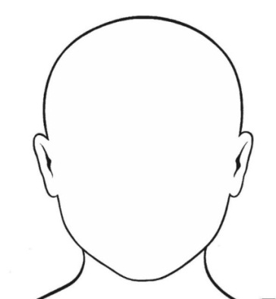

a. His eyes are blue b. His hair is black

c. His hair is curly d. His mouth is big

e. His mouth is smiling f. His hat is red

g. His glasses are black h. His nose is small

i. His nose is small j. His eyebrows are black

4.- Physical descriptions. Draw the silhouettes below according to the sentences presented.

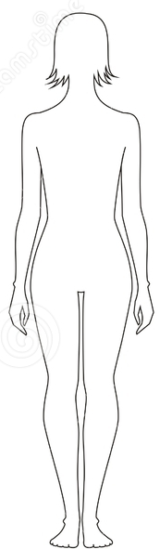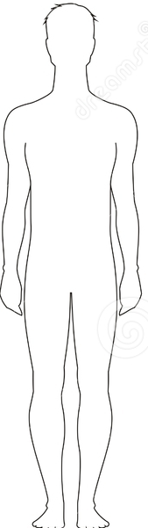

a. His hair is blond b. Her hair is brunette

c. Her jeans are blue d. His shirt is red

e. His eyes are green f. Her shirt is pink

g. Her eyes are brown h. His jeans are black

i. Her shoes are red j. His shoes are white

k. His cap is red l. Her necklace is purple

m. His watch is black n. Her jacket is purple

5.- Match the columns according to the picture.

|  |  |
| --- | --- |
| 1.. The girl is | a) next to the TV |
| 2. The TV is | b) under the desk |
| 3. The book is | c) on the bed |
| 4. The chair is | d) on the desk |
| 5. The mirror is | e) over the sink |
| 6. The jacket is | f) in the closet |

